BRIEFS FOR CLIENTS VISITS
15TH JAN KOREA

Hana Marine 12:00~13:50, 15th Jan., 2024, Seoul

Hyundai LNG Shipping 15:00~16:00, 15th Jan., 2024, Seoul

SINOKOR 16:30~17:30, 15th Jan., 2024, Seoul

Hana Marine

Attendees
-. Suk-Shim Kang / Chairman
-. Joo-hyun Park / CEO of HNCC

Itinerary & Venue 12:00~14:00, Restaurant near Hana Marine

Company profile

Basic information

Foundation : 1987
Major trading partners of major Japanese trading companies, oil refiners, and petrochemical companies
The head office, Busan branch, and overseas offices located in Tokyo are located in three bases, with 50 onshore and 300 marine employees.
Professional transportation of petrochemical products for over 30 years

Fleet list
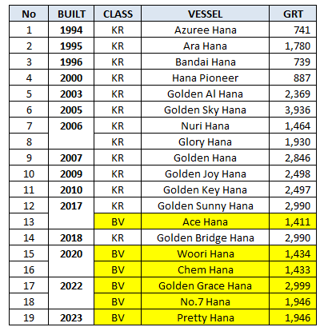

Current and Potential Projects

Current Business with BV

-. NC: 2 ships under construction in Japanese shipyard.
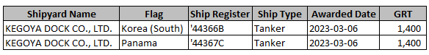

-. NS: 6 NS ships in BV Korea
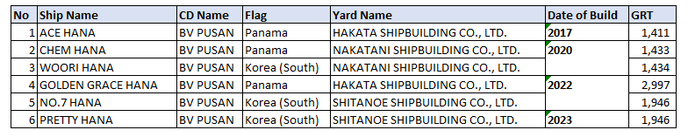

Point of Interest and Focus

-. Due to a crack in the cargo containment welding part of a vessel built at Shitanoe shipyard and delivered in 2022, the chairman of Hana Marine is very concerned that similar defects will occur in the vessels currently under construction at Kegoya shipyard.

-. In this regard, JPO and KPO have been conducting in-depth discussions and investigations with Hana Marine Technical NE team head for a considerable period of time.

-. In this regard, Hana Marine has mentioned that it will make a formal request to the Shitanoe Shipyard site office to dispatch a Korean surveyor, but no official request has been made yet.

CV

Seok-Shim Kang / Chairman of Hana Marine
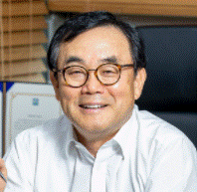

Education
1975 Graduated from Korea University, Department of Law
2006 Graduated from Hankuk University of Foreign Studies, Department of English, Cyber College
2008 Korea University Graduate School of Business, Chief Executive Officer Course Completion
2010 Seoul National University Marine Policy Master Course Completion
-Received Best Paper Award from the Minister of Oceans and Fisheries
Career
1974 Joined the ship department of Cheonwoosa
1977 Korea Chemical Shipping Co., Ltd. Sales Department
1979 Saehan Shipping Co., Ltd. establishment participation business and general affairs
1987 Established Hana Shipping Co., Ltd.
1996 Established Hana Marine Co., Ltd.
2013 Established HNCC Co., Ltd.
2013-2019 Served as a representative and vice-chairman of the Korea Shipping Association (2016-2019)
2019- Served as the chairman of the Small and Medium Tanker Association
2017-19 Chairman of the School Steering Committee of Incheon National Maritime High School
2019-21 Director of Korea Shipping Association
2021 Currently, Hana Marine Co., Ltd. and HNCC Co., Ltd., CEO

Hyundai LNG Shipping

Attendees

Gyu-Bong Lee / CEO
WS Lee / General manager(in business development divison)

Itinerary & Venue 15:00~16:00 in HLS HQ

Company profile

Hyundai LNG Shipping was formed in June 2014 when IMM Private Equity (PE) and IMM Investment formed a consortium to acquire the gas carrier division of the struggling HMM for KRW 1.3 trillion.

Hyundai LNG Shipping has focused on its own divestment process in recent months. IMM PE and IMM Investment have been working to find a buyer for the company, targeting both domestic and foreign parties. HMM entered the bidding war for Hyundai LNG Shipping to fend off overseas acquisitions, but the process was halted when it offered less than the target price.

Hyundai LNG Shipping is South Korea's No. 1 LNG carrier with 10 LNG carriers, four VLGCs and one LNG bunkering vessel under construction. Its annual LNG cargo volume is 5.23 million tonnes. The LPG shipping business started in September 2020.

The owner of HLS is IMM, a private equity fund, which has been trying to sell HLS to foreign capital in the market, but the South Korean government has been encouraging HMM to acquire HLS due to public opinion that selling HLS, which contributes a significant portion of South Korea's LNG import transportation, to foreign capital would expose the country to a critical risk to its energy security, but the market is not yet aware of the final outcome. The latest developments are expected to be heard from the CEO at the meeting.

Fleet list

Ship in service
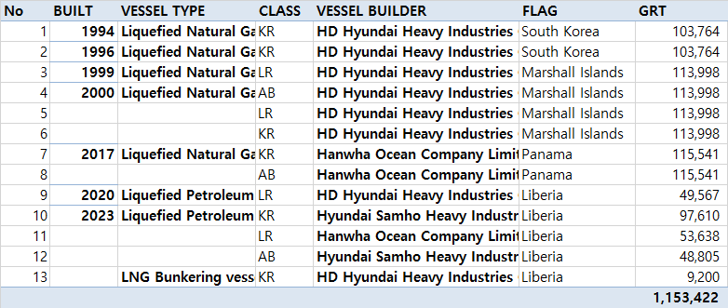

Orderbook
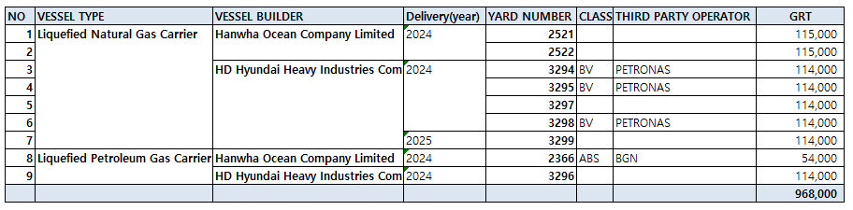

Current and Potential Projects

Current Business with BV

NC
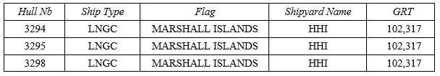

Potential project

Until owner IMM Private Equity (PE) finalises the sale of HLS, it is unlikely to engage in new business for the foreseeable future.

Point of Interest and Focus(Agenda)

Petronas LNGC ceremony

CV

Kyu-Bong Lee / CEO of Hyundai LNG Shipping

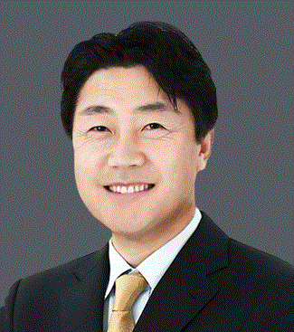

Education
Seogang University(BA)/English Literature
University of Pennsylvania Wharton SchoolMBA /Finance
Career
2018 ~ HYUNDAI LNG SHIPPING
2008 ~ 2017 SK GROUP (SK E&S ,SK Holdings, SK Shipping)
2004 ~ 2008 BP
2002 ~ 2004 Bain & company

SINOKOR

Attendees

Mr. Kum-Ryong Jo / President of SINOKOR SHIP MANAGEMENT
Mr. Jae-Won CHUNG / Head of Planning Department of SINOKOR GROUP

Itinerary & Venue 16:30~17:30, SINOKOR HQ

Company profile

-. The biggest shipping company in Korea. (Officially owned 207 ships. Actually owned 300~400 vessels) i.e. they have about 100 MR Tankers for Shell business with other commercial operator names.
-. Founded in 1989 and embarked on the first liner service between Korea and China in the same year.
-. 97 overseas offices in more than 20 countries
Containers’, bulkers’, tankers’, and logistics business

Fleet list

-. 207 ships in service(source: clarkson)
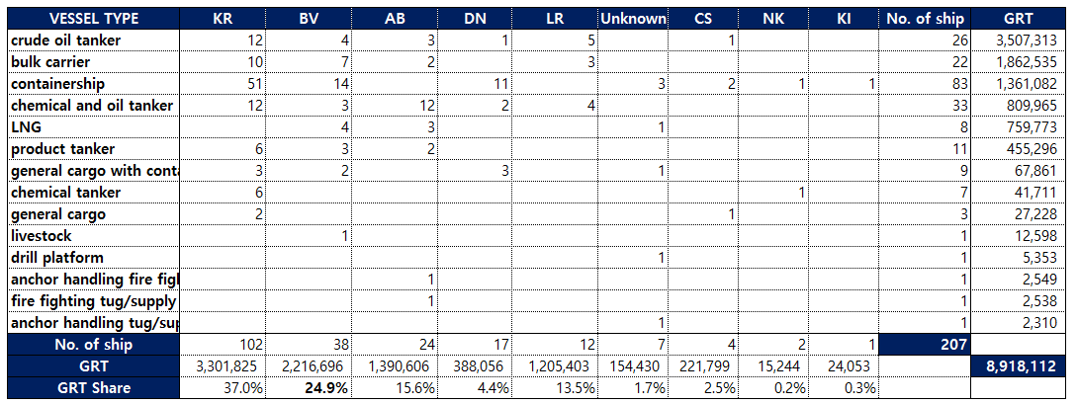

But, market analyst said that SINOKOR has much more number of ships which was not officially informed.

Current and Potential Projects

Current Business with BV

-. NS: 34 ships in service (CD: BV Korea)
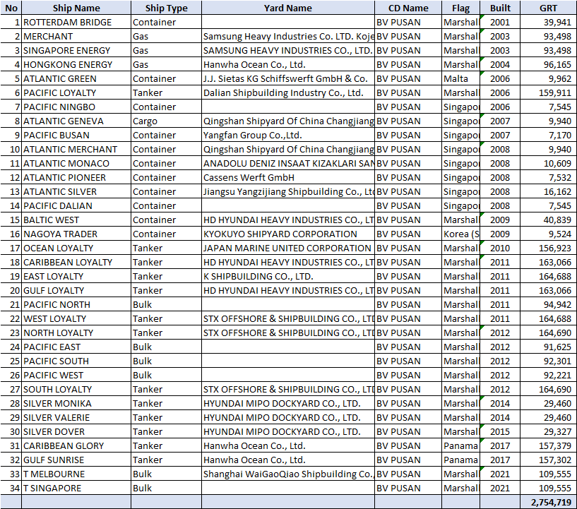

-. NC: 4 ships under construction
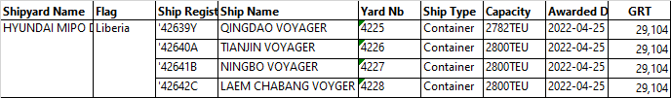

Potential project

-. Frequent CAC discussion recently( 1 CAC is under discussion, and to be reported )

Point of Interest and Focus

Recently, KR Chairman Lee Hyung-chul visited Sinokor, which is KR's largest domestic customer, several times, and dramatically reduced FYF.
In a recent meeting with Sinokor, the head of SINOKOR's planning department said, "Until now, we have been using BV more and more because the FYF level is competitive, but due to KR's recent significant reduction in FYF, BV's FYF is actually higher than KR's, making it less attractive to use BV.
The market analyst said that KR Chairman Lee Hyung-chul has been serving as chairman for a second consecutive term, and according to the rule that KR's chairman must step down after a second term, it is understood that he is taking unconventional steps to make remarkable achievements before he steps down. In this regards, he cut SINOKOR's FYF without considering long term profitability consideration.

In recent years, SINOKOR has made huge profits in the container market boom by buying Hunga Shipping at a low price, and also seems to be making a lot of profits by conducting very active and timely S&P for each ship type. Due to the large amount of capital invested in the S&P of these vessels, there has been no discussion of NC projects recently, and the CAC consultation on the ships being bought and sold continues.

